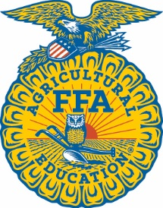
Uintah High School FFA Chapter

Uintah High School FFA Chapter would like to give a big THANKS to the following sponsors for their support! These generous sponsors are helping Uintah FFA Chapter Achieve their mission of Premier Leadership, Personal Growth and Career Success during the 2019-2020 Year.
Thank You!

For more information go to www.uintahffa.com.

Simplot
Countryside Veterinarian Clinic
Ashley Valley Animal Hopsital
IFA
Simply Put Clothing
Wild Mt. Jewelers
Crow Collectibles
Gift Emporium
Vernal Chalet
Krafty Stache
Uintah County Farm Bureau
Zoetis
Flat Rock Construction
KVLE/KLCY Radio
Vernal Express
KXRQ 94.3 Radio
Red Brand Wire
Autozone
Freddy’s
Stellar Field Services
Farmhouse Suckers
Roth Bros Livestock Services
Brandi’s Nails
Western Ag Credit
Ravi’s Floral’s
4 Brother’s Pizza
Mike Phillips
DP Silver
Representative Scott Chew
Wells Fargo
White Smiles Pediatric Dentistry
Randan Vincent
RV Bar Angus
Dry Fork Tack
Dr. Ryan Nelson
Clark Hall
NAPA Auto
Uintah Conference Center
Western Park
Heaston Tire & Wheel
Big O Tire
Bloomers Floral
Mountainland Supply Co.

