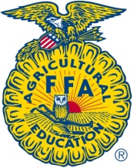
UINTAH FFA CHAPTER SPONSOR FORM
Yes, I would like to support the Uintah FFA Chapter as they strive to help members achieve premier leadership, personal growth and career success. (For more details see attached letter)
I/We our company would like to contribute the amount of:
Company or Individual Name:
Address:
Phone#: Contact Name:
Uintah FFA will recognize your generosity at our Chapter Banquet and in the Vernal Express!
Uintah FFA Chapter Appreciates Your Support!
THANK YOU!

------------------------------------------------------

UINTAH FFA RECEIPT
Invoice#: Sold To:
Invoice Date: Uintah FFA Chapter
Uintah High Federal Tax ID# 87-6000524 Uintah High School
1880 West 500 North
Vernal, UT 84078
435-781-3110 ext. 2720

Item: Uintah FFA Chapter Donation
Description:

Received By: Date:

